**Prerequisites to Install any Java Middleware in a Unix based Machines**

**1.Setting the Correct Hostname**

**After changing the hostname ,reboot the Linux**

**2.Assigning a static IP to a network( firewall rules and User Permissions)**

**3.Install the correct version of Java (JDK or JRE)**

**4.Initiating the installation of Middleware(Websphere Server)**

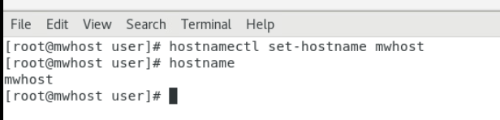

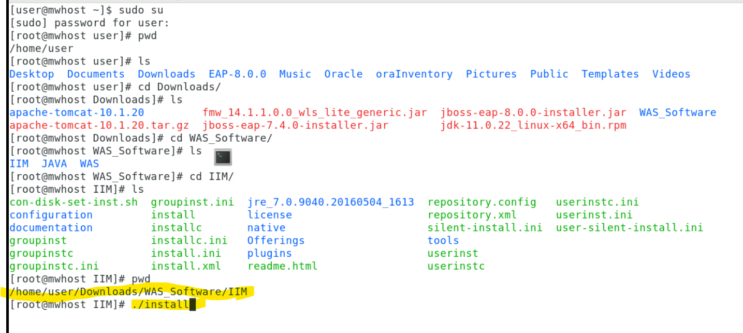

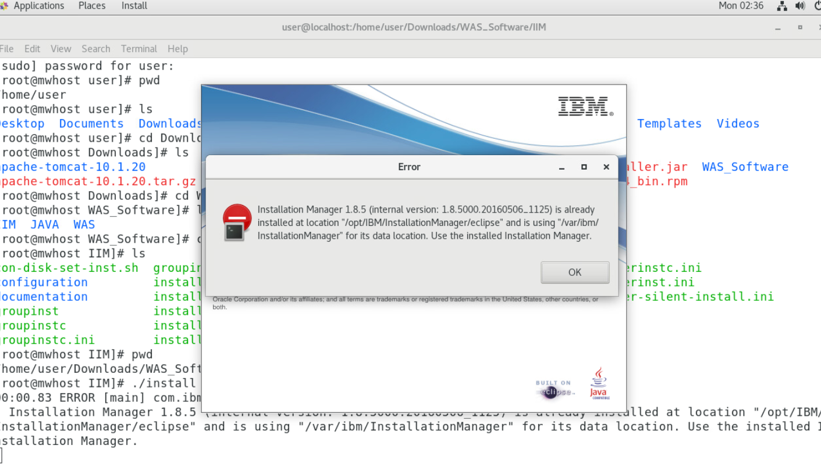

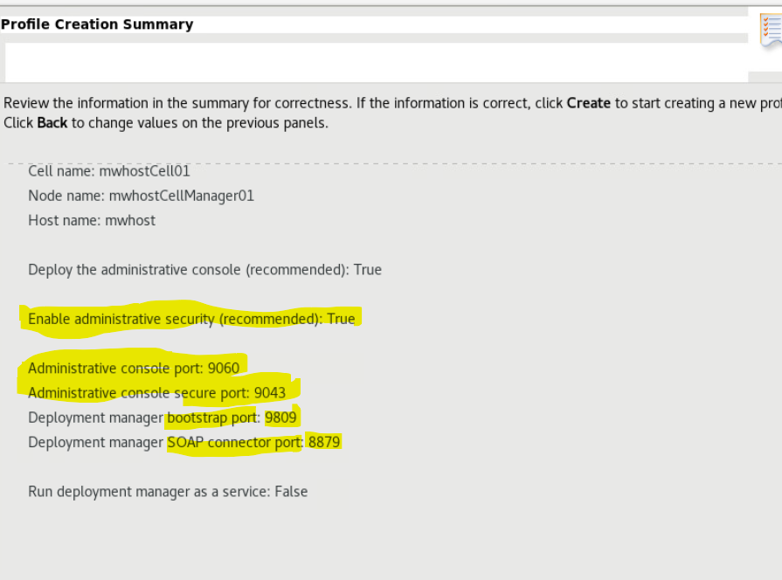

Quick Notes

Websphere Home (Websphere installed location):

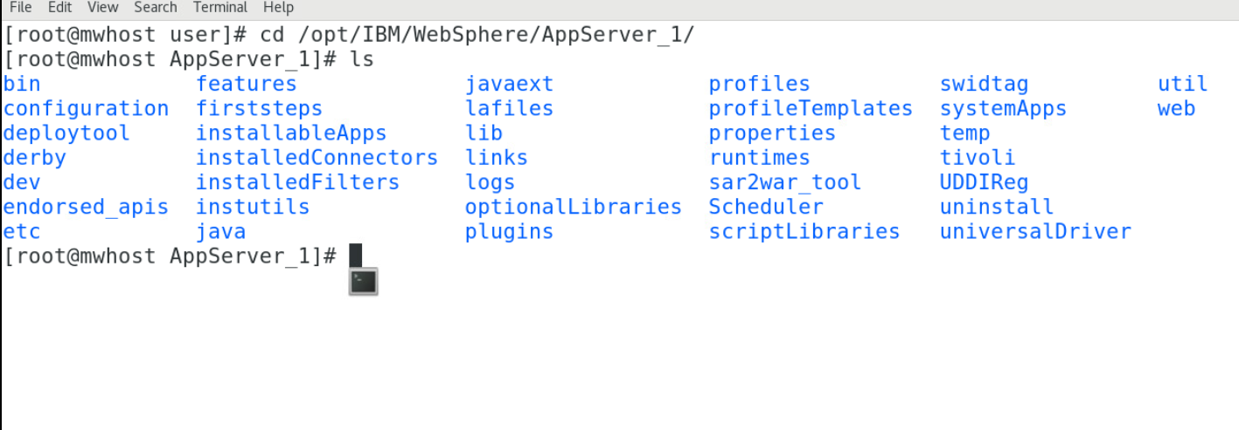

Profile home

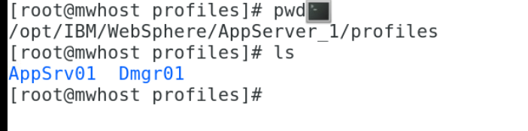

Profile(Dmgr)----🡪Config--🡪cell--🡪nodes(cellmanager)--🡪server(dmgr)

Startup procedure of websphere env:

1.start the ND Server(Deployment Manager-dmgr)

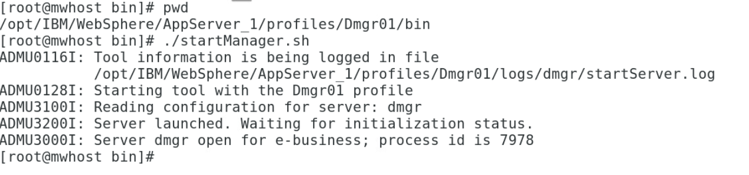

2.login to WAS ND Console

Syntax: <http://hostname:9060/ibm/console> (if users credentials are enabled) then it will redirects automatically to https

<http://mwhost:9060/ibm/console>

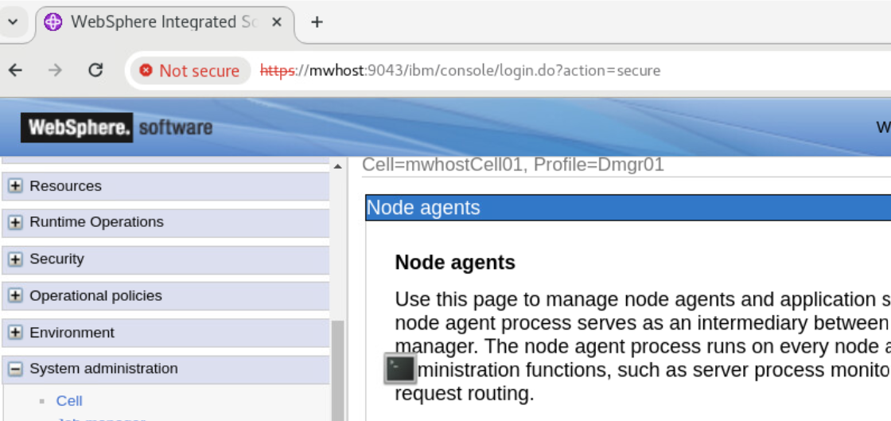

3.start the node agent of each node(profiles)

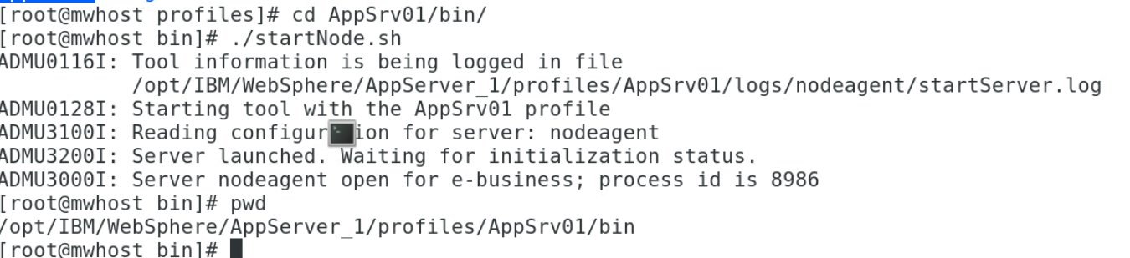

4. start the app.server (using cmd or was console)

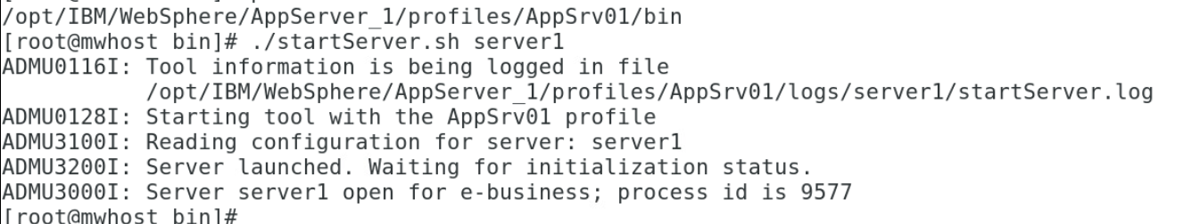

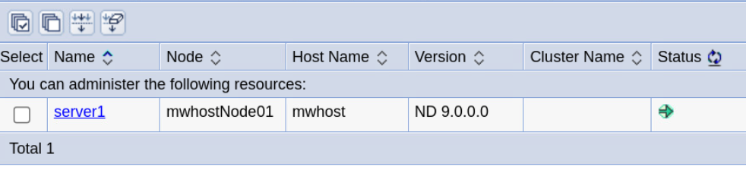

PMT

